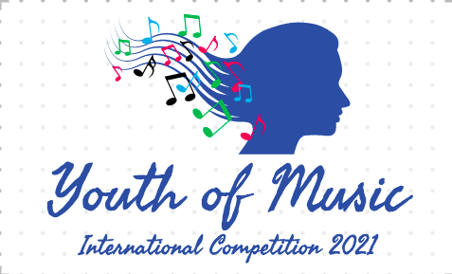



INTERNATIONAL COMPETITION FOR CLASSICAL MUSIC

“Youth of Music” 2021

Application form
窗体顶端

- Name and surname

….…………………………………………………………………………………

- Name and surname of legal representative (in case of minor age participant)

….…………………………………………………………………………………
- Date of Birth
Day/Month/Year…………………………………………………………………
- Nationality
….…………………………………………………………………………………
- Address
Street/City/Province/Country/Zip code
……………………………………………………………………………………
- Email Address, Phone number
….…………………………………………………………………………………

- Age category

….…………………………………………………………………………………

- Music Education Institution (current or last attended music education school/university)

….…………………………………………………………………………………

- Name of the teacher (current or last teachers in the past two years)

….…………………………………………………………………………………

- Competition repertoire

….…………………………………………………………………………………
….…………………………………………………………………………………
….…………………………………………………………………………………
Composer and name of the piece. Should be the same as title of the submitted video link.
- YouTube links for video recordings submitted
….…………………………………………………………………………………
….…………………………………………………………………………………
….…………………………………………………………………………………
….…………………………………………………………………………………
….…………………………………………………………………………………
One music piece = one link.

- Scanned (photographed) page of the official document confirming the identity

….…………………………………………………………………………………

- Name and surname of the payer / In case if other than participant's name

….…………………………………………………………………………………

- Do you agree with the Rules and the Privacy Policy of the “Youth of Music” Online Competition 2021?

Yes

By signing this form, I declare that I read and understood the “Rules and Regulations” of the “Youth of Music” International Competition 2021.

I give my consent to the competition organizers to use my personal data included in this form and in the application documents in conjunction with any activities related to the competition.

Signature Date

….……………………………….. ………………………….

